**The finger of fame**

**名誉之指**

（英文部分选自经济学人20160227讣告）

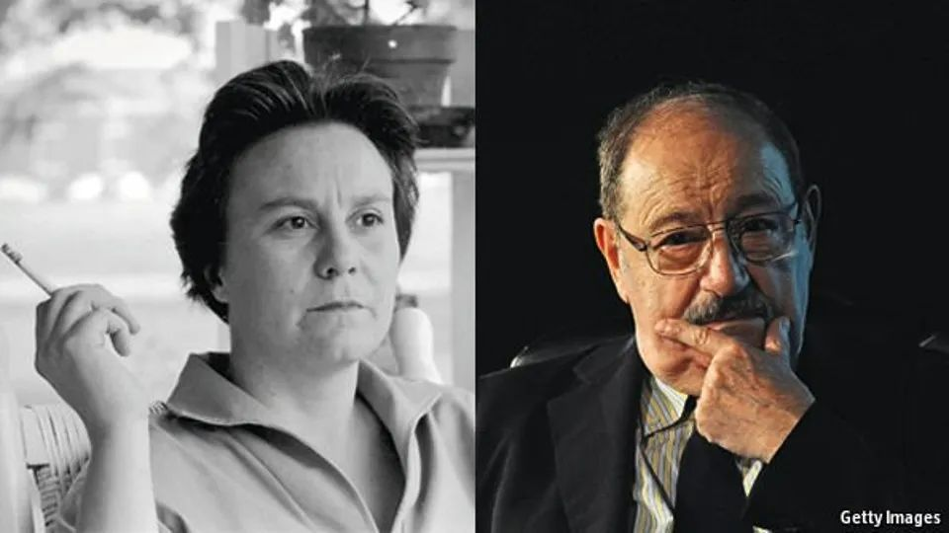

Harper Lee and Umberto Eco

哈珀·李和安伯托·艾柯

The finger of fame

名誉之指

**Harper Lee and Umberto Eco, two unexpected literary celebrities, both died on February 19th, aged 89 and 84**

**2月19日，文坛同日告别两位意想不到的传奇作家，哈珀·李和安伯托·艾柯，享年89岁、84岁。**

SHE was a plain, chubby, chain-smoking southern girl, **living in a cold-water flat in New York** and **working as an airline-reservation clerk**. He was a paunchy, balding, chain-smoking teacher of semiotics, **【**the study of signs, codes and meanings in language】, at various Italian universities. Both enjoyed producing small articles and pastiches, she for the college magazine, he for avant-garde publications, and **it was only challenges from friends** that induced either to **embark on** a novel. His first, “The Name of the Rose”, published in 1980, sold 10m copies worldwide. Her first, “To Kill a Mockingbird” (1960), sold more than 40m, and was proclaimed by some to be the best American novel of the 20th century. Umberto Eco **rode literary stardom like a plump surfer on a giant laughing wave**. Harper Lee was drowned by it.

她是个南方姑娘，模样普通、身材微胖且烟不离手，**住在纽约一间没有热水的公寓里**，**在航空公司上班，负责机票预定**。而他是个大腹便便、“光明顶”日益显现，还烟不离手的老师，在意大利多所大学教授符号学——**这是一门研究符号、密码和语言意义的学问**。两人都喜欢写短文和杂谈，哈珀·李为校刊撰稿，而安伯托·艾柯则为先锋杂志写作。**二人都是在朋友劝说下才开始创作小说**。艾柯的第一部小说《玫瑰之名》于1980年出版，全球销量达一千万册。而李的第一部小说《杀死一只知更鸟》于1960年出版，销量超4千万册，被一些人誉为20世纪最佳美国小说。安伯托·艾柯在文学星途中驰骋，**就像一位强壮的冲浪者出没于巨浪之巅**，而哈珀·李则被巨浪吞没。

“Mockingbird”, set in fictional Maycomb, Alabama, was a story of racial injustice seen through the clear but innocent eye of a small tomboy, Scout, whose father, Atticus Finch, was given the hopeless task of defending a black man accused of raping a white woman. On the eve of the civil-rights era the novel pricked America’s conscience, and reporters raced to photograph Miss Lee in her home town of Monroeville, Alabama, on the porch and in the courthouse, **nervously smiling**. **The book was assumed to be her life in thin disguise**. But in a rare interview in 1961 she said it was all fiction, nothing to do with her “dull” real childhood, and (unspoken but implied) would they please now go away.

《杀死一只知更鸟》的故事发生在阿拉巴马州一个名叫梅科姆的虚构城市里，从假小子斯考特（Scout）清澈无邪的视角讲述了种族不平等现象。斯考特的父亲阿提克斯·芬奇（Atticus Finch）接了一项毫无希望的任务：为一个被指控强奸白人妇女的黑人辩护。在民权时代的前夕，这部小说刺痛了美国人的良知，记者们争相赶往李的家乡阿拉巴马州门罗维尔拍摄她的照片，在家门口门廊和法院里拍摄的照片中，**她拘谨地笑着**。**大家认为这本书就是描写她自己的亲身经历，只不过稍加改编**。但她在1961年一次罕见的采访中说到，这一切都是虚构的，与她“乏味”（“dull”）的真实童年无关，委婉暗示人们不要再打探她的生活了。

Mr Eco would have queried that wished-for divide between fact and fiction. It wasn’t as clear-cut as that. The urge to tell stories, weave myths and simply lie lay deep in the possibilities of human language. But if facts could become fables, fables could lead to facts, just as wild medieval tales of lost kingdoms had inspired Europe’s exploration of America. Besides, any novel pretended to be true, and a good “open” text would spur the reader to judge and interpret that truth for himself. “Mockingbird” and “The Name of the Rose” were both essentially whodunnits, and “Who done it?” Mr Eco said, was the fundamental question of all philosophy.

艾科则对人们希望划清现实和虚构界限的想法提出质疑。两者并非泾渭分明。讲故事、编神话以及说谎的欲望深根于人类语言的各种可能性之中。但是如若事实能变成故事，故事亦能指向事实，正如中世纪那些关于已灭亡的王朝的故事亦可激发欧洲对美洲的探索一样。更何况任何一本小说都意在营造真实，而好的“开放性”文字能激发读者形成自己的判断和对真相的理解。《杀死一只知更鸟》和《玫瑰之名》本质上都是悬疑小说，而按照艾科的说法“凶手是谁？”这个问题是所有哲学要回答的根本命题。

His own journey through the labyrinth described an investigation by William of Baskerville and his sidekick, the novice Adso, into a series of gruesome murders in an unnamed abbey in the year 1327. **He began with a pleasing idea**, that a monk might be poisoned by reading a book, and took it from there, lovingly channelling the Middle Ages and **pouring forth everything he knew**. Again, though this was fiction, pages covered the theological, philosophical and scientific debates **of the time**, well-dosed (for those who knew) with his own semiotics in medieval dress.

艾科的悬疑小说讲述了1327年，巴斯克维尔的威廉（William）和他的伙伴见习修士阿德索（Adso）对发生在一所无名修道院内的一系列可怕谋杀案的调查。他**先是从一个令人满意的想法开始**，即一个僧侣可能会因为读一本书而中毒，由此，亲切地引入中世纪，**将自己所知尽数道出**。其次，虽然这是一本小说，但书页里涵盖了**当时的**神学、哲学和科学辩论，在中世纪的外衣下，他插入的符号学内容恰如其分（对于那些知道的人来说）。

Both he and Miss Lee dealt in sealed-off worlds: Maycomb isolated in cotton fields and quiet red dust; the abbey perched on precipices behind high walls. In such worlds rumours festered and conspiracy theories proliferated, fed by the feverish interpretation of signs. Both featured places (in the abbey, the library; in Maycomb, the tumbledown Boo Radley house) peopled by shadows and littered with symbols. In the abbey, painted phrases from the Apocalypse beckoned towards horror. In Maycomb, Indian-head pennies left in a tree seemed to do the same.

艾科和李的作品都设立在封闭的世界：梅科姆被棉花地包围，笼罩在安静的红尘中与世隔绝；修道院则坐落在悬崖上，四周高墙环绕。在这样的世界里，谣言滋生，阴谋发酵，符号被大肆解读。书中两个特定的地方（修道院里的图书馆；梅科姆里，布·拉德力那摇摇欲坠的房子）都充斥着阴影，散布着符号。在修道院里，《启示录》里摘出的词句预示着恐怖。在梅科姆，留在树上的铸有印第安人头像的硬币也似乎预示着不祥。

Despite her protests, Miss Lee’s minute evocation of Maycomb—the talcum scent of white women in the humid afternoons, the smell of Hoyt’s Cologne in the blacks’ church—was evidently **drawn from** childhood. And she had honed her skills of observation afterwards when Truman Capote, a childhood friend, took her along in 1959 to help with the exhaustive forensic interviews in Holcomb, Kansas that became “In Cold Blood”. Mr Eco, who worked from notebooks, index cards, obscure codices and hand-drawn maps, was seldom autobiographical, save for musing on the seductive symbols and myths of fascism with which he had grown up; and save for reflecting that his omnivorous curiosity, his love of lists and lunatic science (“Ptolemy, not Galileo”) and his analysis of every conceivable cultural artefact, from Thomas Mann to Mickey Mouse, from Snoopy to Avicenna, from TV quiz shows to the “Poetics” of Aristotle, had been fed in boyhood by reading Jules Verne.

尽管李不愿把小说和她的生活混为一谈，但她对梅科姆的细致描写——白人妇女在潮湿的午后散发出的滑石气味，黑人教堂里霍伊特古龙水的味道——显然来自于她的童年经历。1959 年，儿时的好友杜鲁门·卡波特带她到堪萨斯州的霍尔科姆参与了一次细致的司法问询，这段经历后来被写成了小说《冷血》。艾科研究笔记、索引卡、晦涩的抄本和手绘地图，他的作品有对符号寓意以及法西斯的各种传说的思考——他的少年时代正值法西斯盛行；少年时期阅读凡尔纳激发了他旺盛的好奇心，让他热爱列表和荒诞的科学（“托勒密，而不是伽利略”），同时他也分析各种文化艺术品，从托马斯·曼到米老鼠，从史努比到阿维森纳，从电视问答节目到亚里士多德的《诗学》，这些都反映在他的作品中。除此之外，他的作品很少与自身经历有关。

## ****Opening the text****

**开放文本**

Sudden fame encouraged him all the more. He travelled the globe, wrote columns for left-wing newspapers and produced six more novels: one, “Foucault’s Pendulum” (1988), about an all-encompassing conspiracy theory; another, “Baudolino” (2000), about webs of lies. All sold well. In his several residences he amassed a collection of 50,000 books; but he still spent five days a week merrily teaching semiotics in Bologna, partly at the university and partly, till late, in the tavernas of the town.

一举成名给了艾科更多鼓励。他周游全球，为左翼报纸撰写专栏，继续创作了六本小说：其中一本叫《傅科摆》（1988），讲的是一个包罗万象的阴谋论；另一本《波多里诺》（2000），是关于谎言之网。都卖得很好。他在自家多处居所里收藏了5万本图书；但他仍然每周花上五天时间在博洛尼亚愉快地教授符号学，一部分时间在大学里授课，一部分时间在镇上的希腊酒馆里教到深夜。

Harper Lee vanished. The second novel would not come, and she retreated to Monroeville. In 2015 the discarded part of “Mockingbird” was published as “Go Set a Watchman”, to tepid reviews. She too, in confused old age, was indifferent to it. But in Bologna one professor might have noted that “Watchman”, in which the noble Atticus suddenly expressed racist opinions, had opened up “Mockingbird” to new and startling interpretations: which surely should encourage the millions who loved it to read it all over again.

成名后哈珀·李却消失了。她的第二部著作再未出现，本人回到门罗维尔隐居。2015年，《知更鸟》里被弃掉的部分取名《守望之心》出版，反响平平。而晚年意识不清的李，同样对该书无动于衷。但在博洛尼亚，一位教授兴许指出过，《守望之心》中，高贵的阿迪克斯突然发表种族主义言论，这让读者对《知更鸟》有了令人震惊的全新解读：而这一定会鼓励喜爱该书的数百万读者再次开卷通读。